ORB - Oriented FAST and Rotated BRIEF
ORB is a fusion of FAST Keypoints detector and BRIEF descriptor with many modifications to enhance performance. First it uses FAST to find Keypoints, then apply Harris corner measure to find top N points among them.
It computes the intensity weighted centroid of the patch with located corner at center. The direction of the vector from this corner point to centroid gives the orientation. To improve the rotation invariance, moments are computed with x and y which should be in a circular region of radius r, where r is the size of the patch.
ORB discretizes the angle to increments of 2π/30 (12 degrees) and constructs a lookup table of precomputed BRIEF patterns. If the Keypoints orientation θ is consistent across views, the correct set of points Sθ will be used to compute its descriptor.
FAST - Features from Accelerated and Segments Test, given a pixel p, the surrounding pixels are sorted into three classes (lighter than p, darker than p or like p). If more than half are brighter than p than it is selected as a keypoint. So keypoints found by fast gives us information of the location of determining edges in an image.
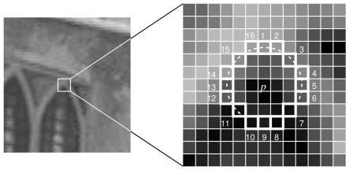
Figure 7 kernel type example

However, FAST features do not have an orientation component and multiscale features. An image pyramid as seen below is used. Each level in the pyramid contains a down sampled version of the image than the previous level. Orb uses the fast algorithm to detect keypoints in the image. By detecting keypoints at each level orb is effectively locating key points at a different scale. In this way, ORB is partial scale invariant.
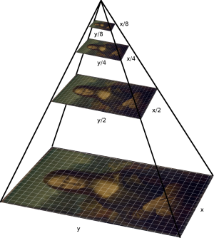
Figure 8 multiscale layers example

To have orientation invariance we will assign an orientation to each Keypoint, depending on the levels of intensity. Calculation of the orientation happens as follows:
First, the moments of a patch are defined as:
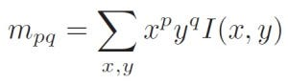
Equation 9
With these moments we can find the centroid of the “patch”:
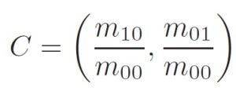
Equation 10
And use the centroids to construct a vector from the corner’s center O to the centroid The orientation of the patch is then given by:
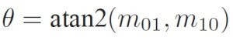
Equation 11
Brief(Binary robust independent elementary feature) Brief takes all keypoints found by the fast algorithm and converts it into a binary feature vector.

BRIEF has an important property that each bit feature has a large variance and a mean near 0.5. But once it is oriented along a Keypoint direction, it loses this property and becomes more distributed. High variance makes a feature more discriminative since it responds differentially to inputs. Another desirable property is to have the tests uncorrelated, since then each test will contribute to the result. To resolve all these, ORB runs a greedy search among all possible binary tests to find the ones that have both high variance and means close to 0.5, as well as being uncorrelated. The result is called rBRIEF.

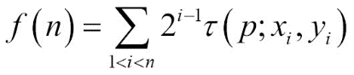
Equation 12
Keypoints are the same thing as interest points. They are spatial locations, or points in the image that define what is interesting or what stands out in the image. Interest point detection is a subset of blob detection, which aims to find interesting regions or spatial areas in an image. The reason why keypoints are special is because no matter how the image changes... whether the image rotates, shrinks/expands, is translated (all of these would be an affine transformation by the way...) or is subject to distortion (i.e., a projective transformation or homography), you should be able to find the same keypoints in this modified image when comparing with the original image.
It uses the patch orientation θ and the corresponding rotation matrix Rθ, and construct a steered version Sθ of S:
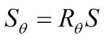
Equation 13

Now, the steered BRIEF operator becomes:

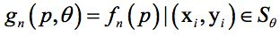
Equation 14

